|  |
| --- |
| **FSEATS** |
| APTECH F.B AREA Center |
| **Project Certification** |
|  |



***FSEATS***

**E-Project**

**Android-Food Choice App**

Submitted To:

eProjects@aglsm.com

Project Instructor:

Sir Faizan

Group Members:

|  |  |  |  |  |  |  |  |  |  |  |  |
| --- | --- | --- | --- | --- | --- | --- | --- | --- | --- | --- | --- |
| |  |  |  | | --- | --- | --- | | |  | | --- | | **Syeda Fazila Wali 1240120**  **Sumna Imran 1240103** | |  | | |  |  | | --- | --- | |  |  | |  | |  |  | | |  |
|  |
|  |

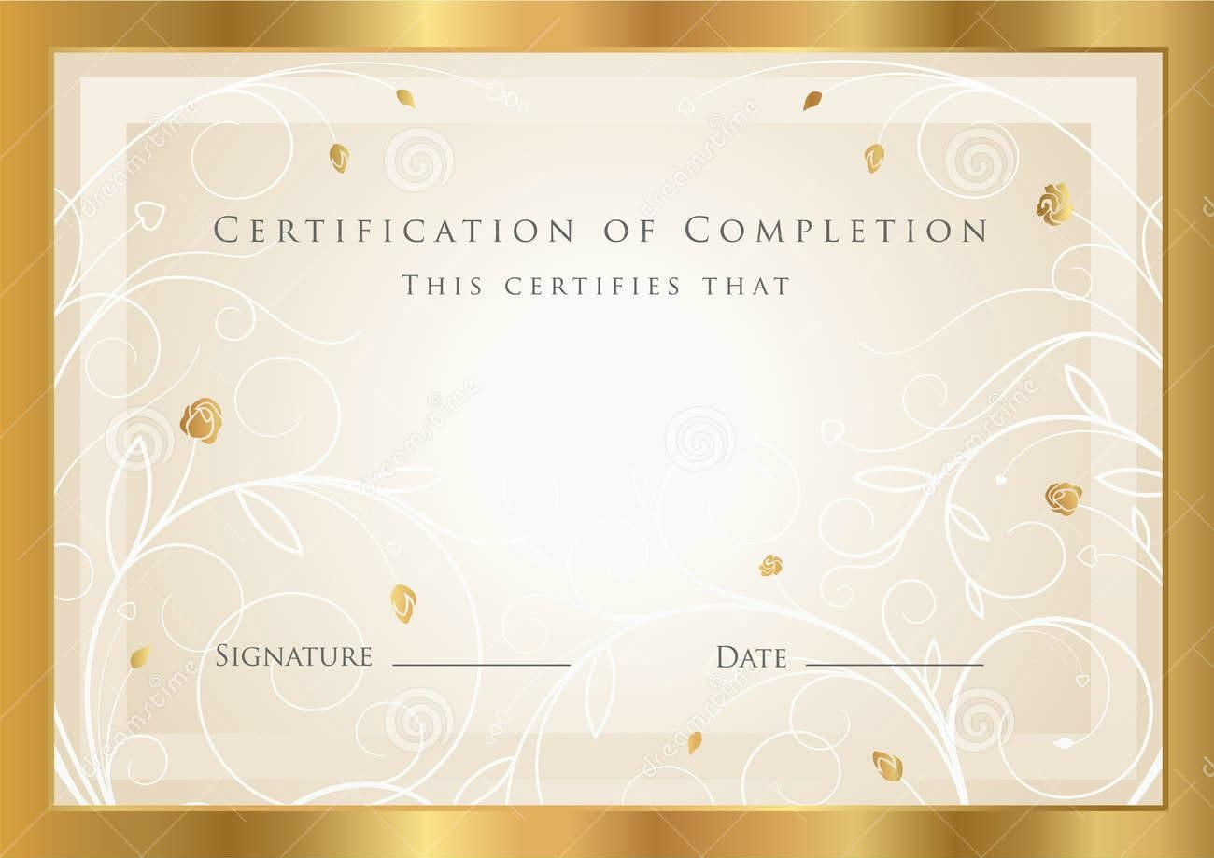

**Syeda Fazila Wali 1240120**

**Sumna Imran 1240103**

## Has successfully Design and Developed

# EXCELLENT COACHING

## Submitted by:

**Syeda Fazila Wali**

**Sumna Imran**

***Sir faizan 25-August-2021***

***Acknowledgement:***



We like to thank many people who helped us in completing this project. Formost I would like to thank Almighty Allah for giving us strength and ability to complete this project. We would like to express our gratitude to all those who gave us the possibility to complete this website and we want to thank the Department of faculty for helping us to do the necessary research. We furthermore, thanks to our class teacher Sir Zuhaib Imran our Great Teacher and also our Faculty Instractor

Sir Yasir Ameen for giving us completes support and advising us in the project.

Thank You.

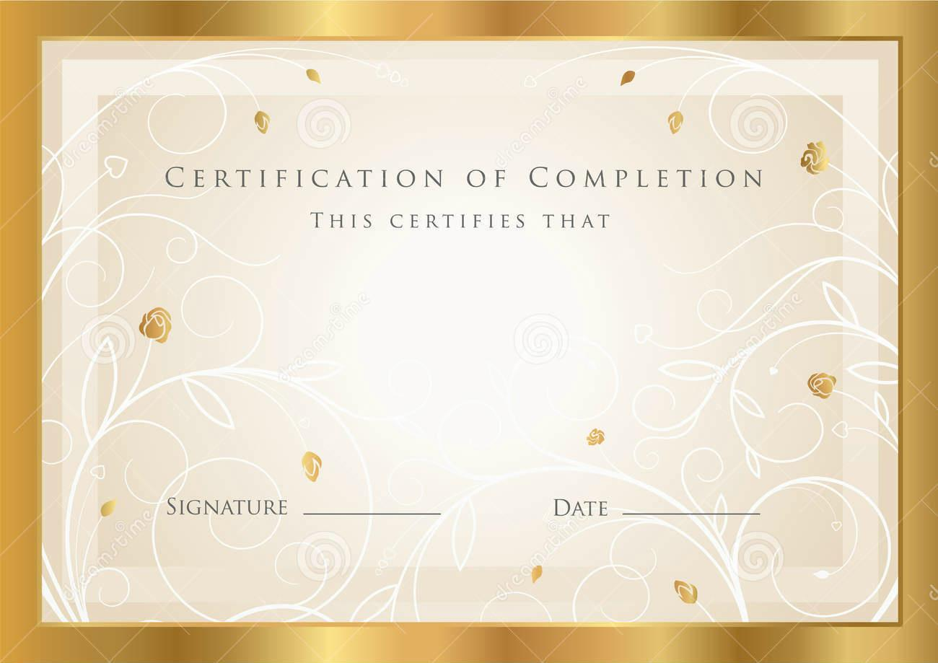**TABLE OF CONTENTS**

PROJECT CERTIFICATION……………………………………………………………………….

acknowledgement……………………………………………………………………………..

TABLE OF CONTENTS………………………………………………………………………………

PROBLEM DEFINITION…………………………………………………………………….…..

INTRODUCTION……………………………………………………………………………………

Task sheet…………………………………………………………………………………………..

LIST OF VALIDATION……………………………………………………………………………

SUBMITION CHECKLIST………………………………………………………………………..

User guide…………………………………………………………………………………..

Summary……………………………………………………………………………………………

Screen shot……………………………………………………………………………….…

Source code……………………………………………………………………………….…

|  |  |  |  |  |  |
| --- | --- | --- | --- | --- | --- |
| Sr. | Task | Actual Start Date | Actual Days | Team Mate Name | Status |
| 1. | Information Collecting | 03-Aug-2021 | 02 | Sumna Imran, Syeda fazila wali | **Completed** |
| 2. | Making Logo | 05-Aug-2021 | 01 | Sumna Imran | **Completed** |
| 3. | Making Layout/Pages | **06-Aug-2021** | 10 | Sumna Imran | **Completed** |
| 4. | Connecting Links | 15-Aug-2021 | 02 | Sumna Imran, Syeda Fazila wali | **Completed** |
| 5. | Application Testing | 17- Aug-2021 | 04 | Sumna Imran | **Completed** |
| 6. | Images Collection | 21- Aug-2021 | 02 | Sumna Imran | **Completed** |
| 7. | Documentation | 24-Aug-2021 | 2 | Syeda fazila wali | **Completed** |

**Task Sheet**

**LIST OF VALIDATION**

|  |  |
| --- | --- |
| **Option** | **Validation** |
| Fields In Form should not be Null | **Yes** |
| Homepage Has Forward Only Link | **Yes** |
| All Webpages have link back to Homepage | **Yes** |
| Request Quote Form Included | **Yes** |
| All Pages opens in mainframe (iframe) | **Yes** |
| All Functions Are Compatible with Google Chrome | **Yes** |

# SUBMISSION CHECKLIST

|  |  |  |  |  |
| --- | --- | --- | --- | --- |
| **S.NO** | **LIST OF ITEMS** | **YES** | **NO** | **COMMENTS** |
| 1. | Do All Pages Linked together | **Yes** |  |  |
| 2. | All Hyperlinks working | **Yes** |  |  |
| 3. | Site Browser Compatible | **Yes** |  | **Tested Google Chrome,Firefox,IE8** |
| 4. | Project Zip File | **Yes** |  | **Created using WinRAR** |

**User Guide:**

**Disclaimer:**

Not all these design features are appropriate in all cases. There are always exceptions, and there are lots of bad examples of these features being used wrongly, over-used, or done without sensitivity to the “symphony” of a site’s design.

You can’t just take all these elements, throw them together and make a good web page, any more than you can take some eggs, sugar, flour and throw them together and get a cake.

Making a web page that works requires a lot of sensitivity to the various forces at work. A good design solution is one that balances those (often opposing) forces.

Introduction

The thirst for learning, upgrading technical skills and applying the concepts in real life environment at a fast pace is what the industry demands from IT professionals today. However busy work schedules, far-flung locations, and unavailability of convenient time-slots pose as major barriers when it comes to applying the concepts into realism. And hence the need to look out for alternative means of implementation in the form of laddered approach.

The above truly pose as constraints especially for our students too! With their busy schedules, it is indeed difficult for our students to keep up with the genuine and constant need for integrated application which can be seen live especially so in the field of IT education where technology can change on the spur of a moment. *Well,* *technology does come to our rescue at such times!!*

Keeping the above in mind and in tune with our constant endeavour to use Technology in our training model, we at Aptech have thought of revolutionizing the way our students learn and implement the concepts using tools themselves by providing a *live and synchronous eProject learning environment!*

**So what is this E- Project?**

E-Project is a step by step learning environment that closely simulates the classroom and Lab based learning environment into actual implementation. It is a project implementation at your fingertips!! An electronic, live juncture on the machine that allows you to

* Practice step by step i.e. laddered approach.
* Build a larger more robust application.
* Usage of certain utilities in applications designed by user.
* Single program to unified code leading to a complete application.
* Learn implementation of concepts in a phased manner.
* Enhance skills and add value.
* Work on real life projects.
* Give a real life scenario and help to create applications more complicated and useful
* Mentoring through email support.

**How do we start accessing the Sample eProject?**

The students at the center are expected to complete this eProject and send complete documentation with source code within the time allotted to eProjects Tea.

Looking forward to a positive response from your end!!

Objectives of the project

The Objective of this program is to give a sample project to work on real life projects. These applications help you build a larger more robust application.

The objective is not to teach you the software s but to provide you with a real life scenario and help you create basic applications using the tools.

You can revise the chapters before you start with the project.

These programs should be done in the Lab sessions with assistance of the faculty if required.

It is very essential that a student has a clear understanding of the subject.

Kindly get back to eProjects Team in case of any doubts regarding the application or its objectives.

.



Problem Statement

Food Choice App

The main aim of developing this Android-based mobile Carve your Choice Food App is to provide easy food application to the users those who want to explore tasty food in their kitchen. This app can be helpful to the newcomers to prepare delicious food.

**EXISTING SOLUTION**

* Displays only recipe description by selecting the particular recipe
* only shows grocery items
* individual details of each ingredient

**PROBLEM**

* Many people want to do a variety of recipes in their homes.
* Some people may have a habit of preparing a variety of cuisines in their homes and they try to browse and cook.
* Here there is a problem arises of ingredients, some may be available may not be available and it takes more time to search and can’t find nutrition facts directly.

**DISADVANTAGES OF EXISTING SOLUTION**

* Manually typing about the items
* Doesn’t show each and every detail of vegetables
* It requires more time to search for recipes.

**PROPOSED SYSTEM**

We are going to provide a Carve your Choice Food App for different ingredients like organic food and inorganic food materials with their use cases and also we are linking up with videos so that everyone can access easily

**ADVANTAGES OF PROPOSED SYSTEM**

* Time-saving, Conduit-free setup, and maintenance
* Ease of Use and Implementation
* It is useful for bachelors
* The people who don’t know cooking
* It can show the diet details so that we can follow healthy tips

**MODULES**

***User (My Recipes):***

Users can add and edit the recipes of their choice.

***Grocery list:***

Users can select any type of ingredients according to the categories existing in the database and can prepare their cuisines.

***Cook Recipes:***

The user can find many varieties of recipes and can choose their favorite ones to prepare.

***Meal Planner:***

According to the person, they can plan their diet for the whole day that is breakfast, lunch, and dinner.

***Kitchen tips and tricks:***

People can follow some of the tips that they need for their kitchens.

**CONCLUSION**

As our food-related idea is useful for a number of people we are providing features for literate and illiterate people so that the person can easily understand and they can prepare any type of recipe using this app and can learn the easy way of cooking with their available items.

 **Hardware/ Software Requirements**

**Hardware**

* Android mobile with a minimum version 2.2.
* The processor is not less than 500MHZ.
* RAM is not less than 2048MB.
* SD card with a minimum of 512MB.
* Resolution is not less than 480*800pixs.

**Software**

Use software as per your requirement

* Windows OS/JAVA/Android SDK/Notepad/SQL/Android 2.2 or Later



Our Plan And Our Idea Was To Provide Maximum Output In The Minimum Time. We Tried To Make Our Database Secure And Well Managed So That Everybody Know About The Process Of Pharmaceuticals Easily. We Make An Easiest Way To Full Fill Form Requirement.



Database

Design



TEAM LEADER

ASSIGNED

DUTIES TO ALL

TEAM

MEMBERS



Testingnon

**On** Emulator



Coding

Testing



Design

Application

Layout

Project Review and Monitoring Report.

*First of all, group projects force you to work with your group members.*

*Unfortunately, as we all know, is doesn’t happened before but in this the real mirrors world, where you don’t get to choose your co-workers. Learning how to deal with someone who slacks, is confrontational or is nonresponsive is imperative to have a happy and successful work life.*

*We’ve learned how to work together as a team, what to do, such a nice criteria of studies we have by aptech, how to contribute in ideas, our minds start resolving errors, and giving us many ideas. Whole team is so much thankful to aptech learning, for giving us an opportunity to explore ourselves, we’ve to learned or practices more & more to make our skills best.*

*As it was our fourth semester(hdse II |) project of Android, we* *would like to express our special thanks to our faculty sir* **Faizan***, who helped us through thick and thin and guided us like a real mentor, we would like to thanks our batch coordinator as well, Sir faizan who gave us the golden opportunity to do this wonderful project of ANDROID-Food Choice* App *, which also helped us to master our skills in designing, programming and database and we came to know about so many new things we are really thankful to them.*

**Home Page**

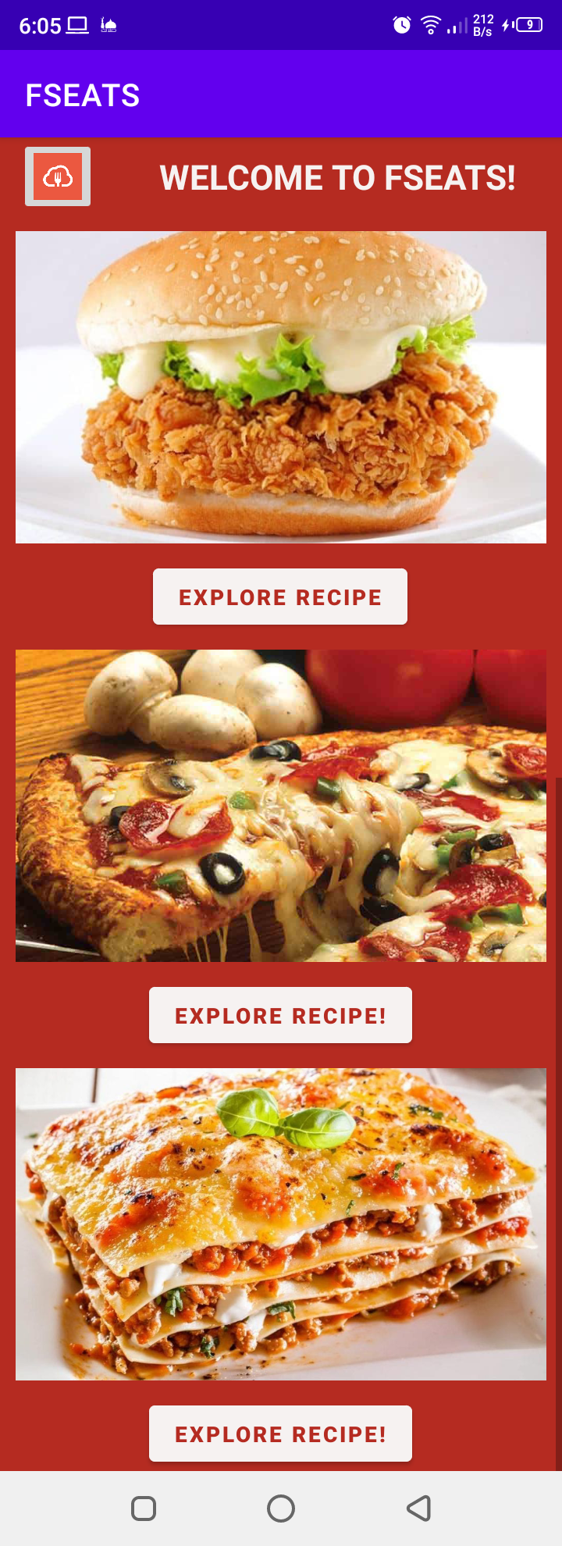

**Burger Homepage**

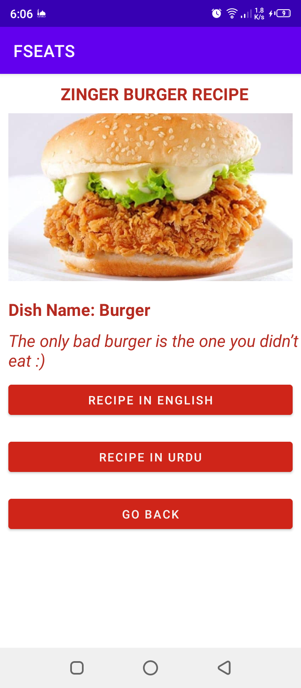

**Burger Recipe in English**

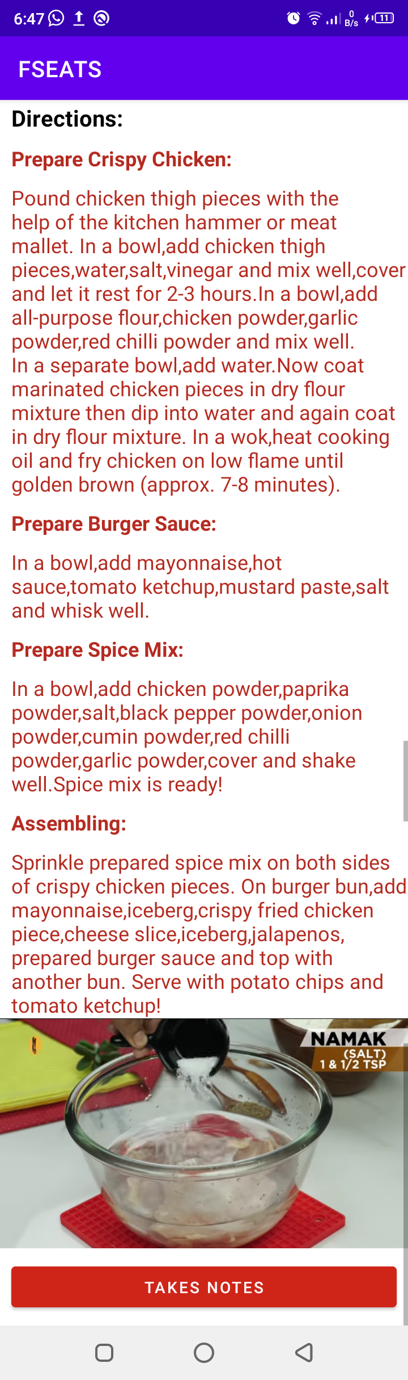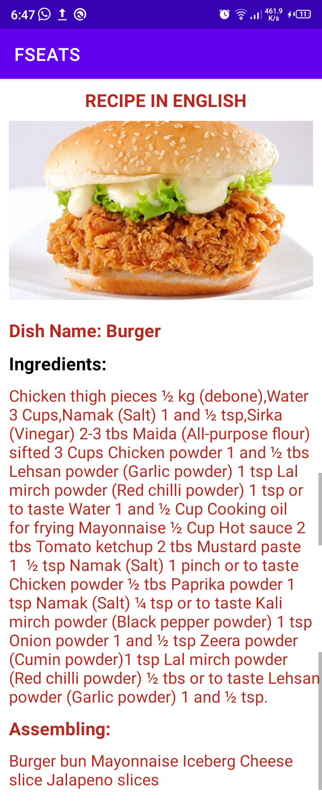

**Burger Recipe in Urdu**

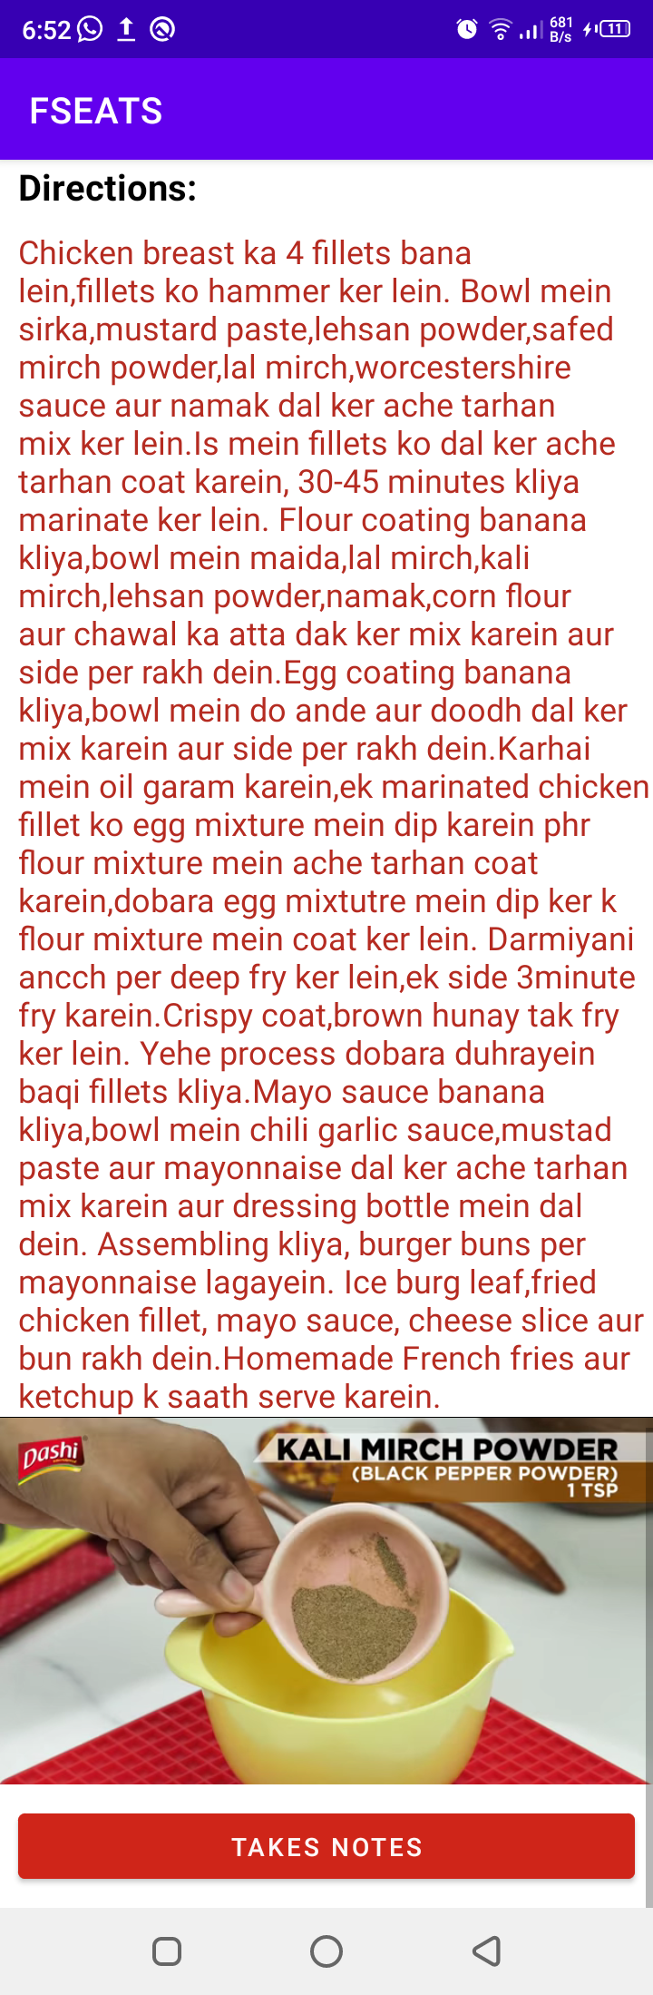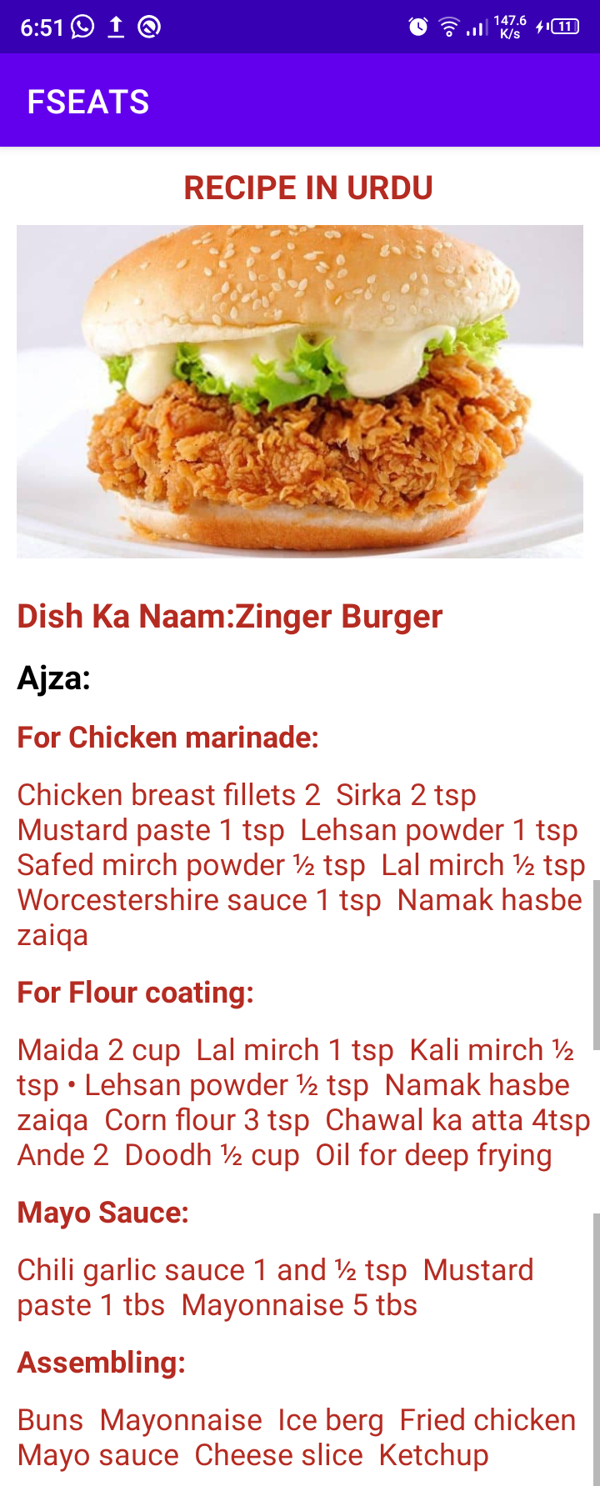

**Pizza HomePage**

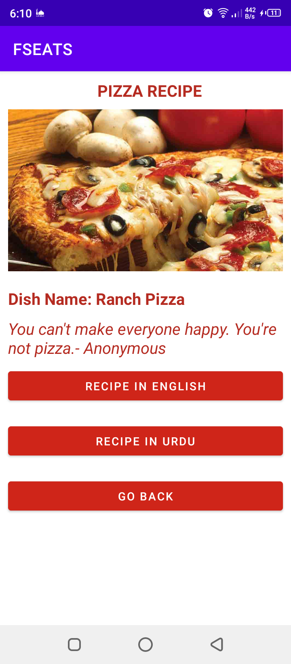

**Pizza recipe in English**

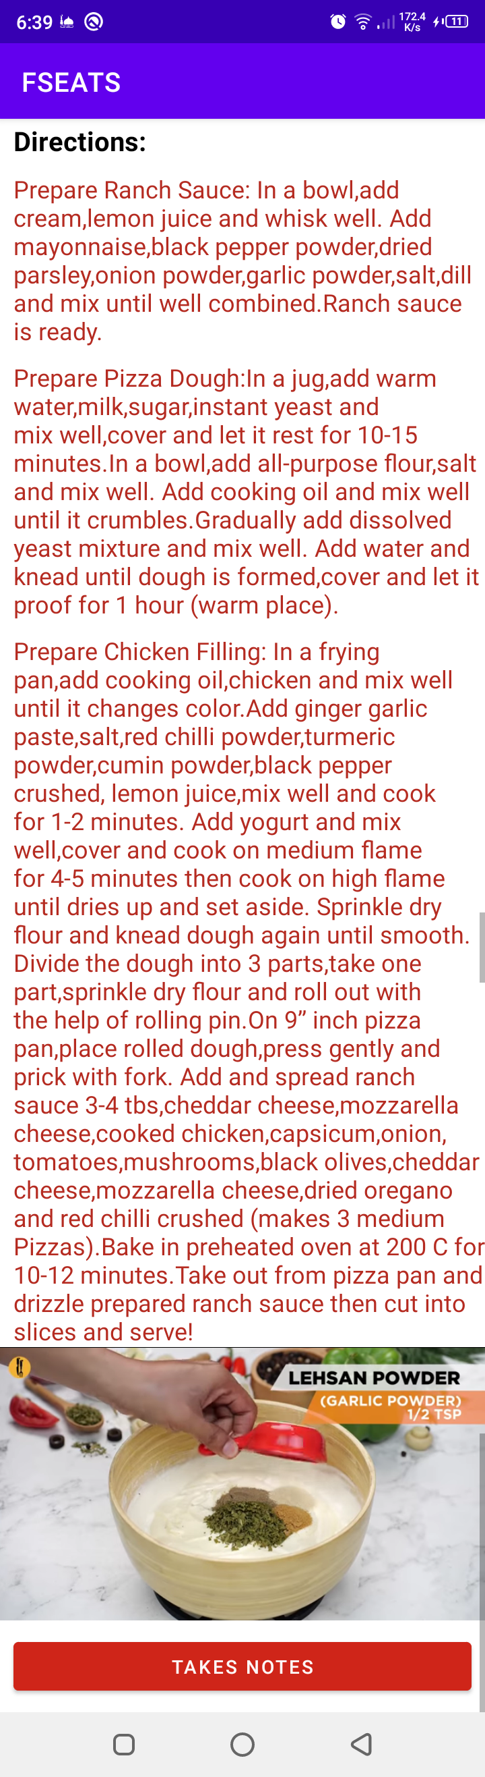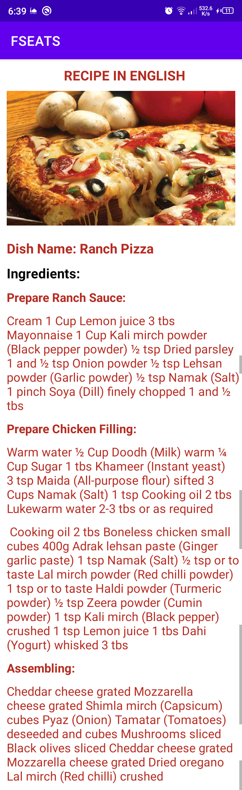

**Pizza Recipe in Urdu**

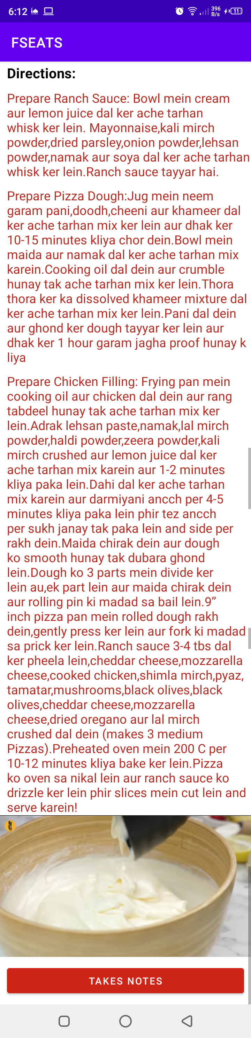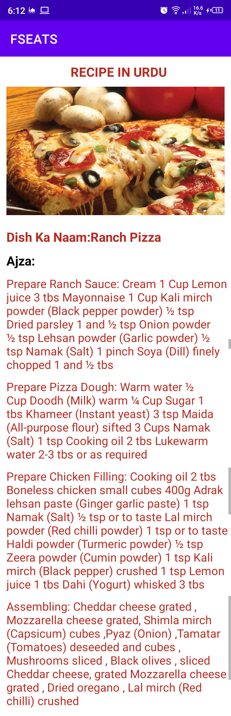

**Lasagna Home Page**

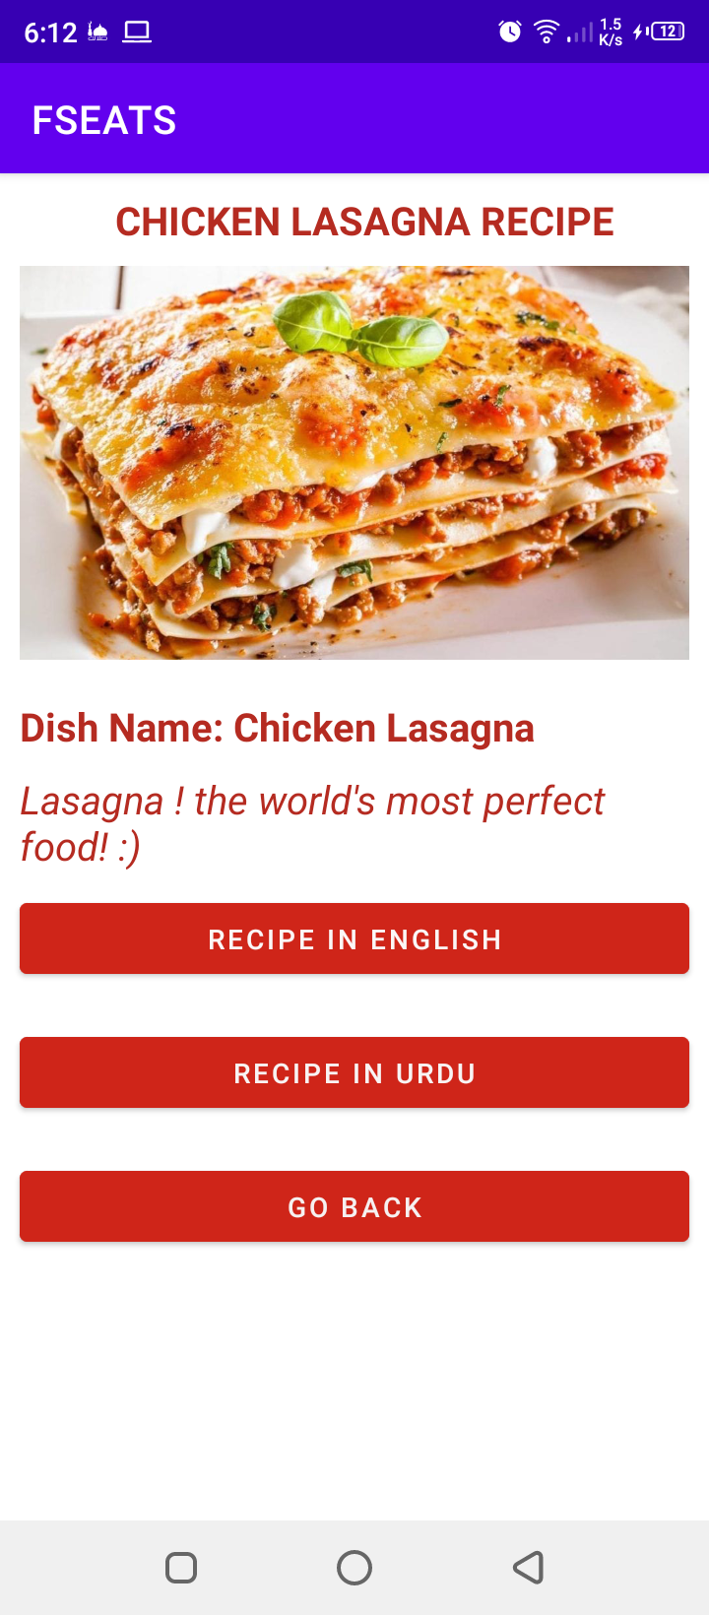

**Lasagna Recipe in English**

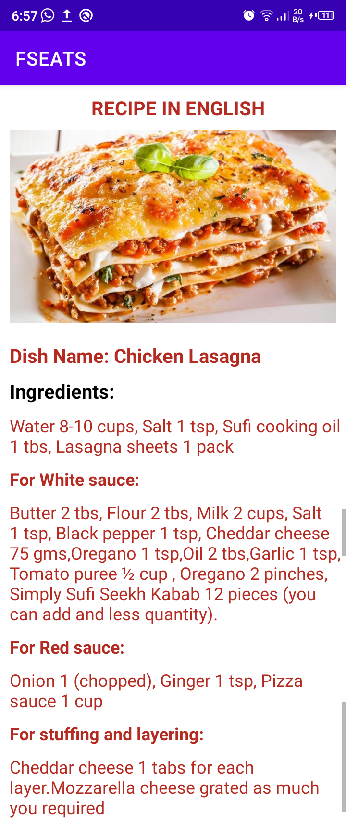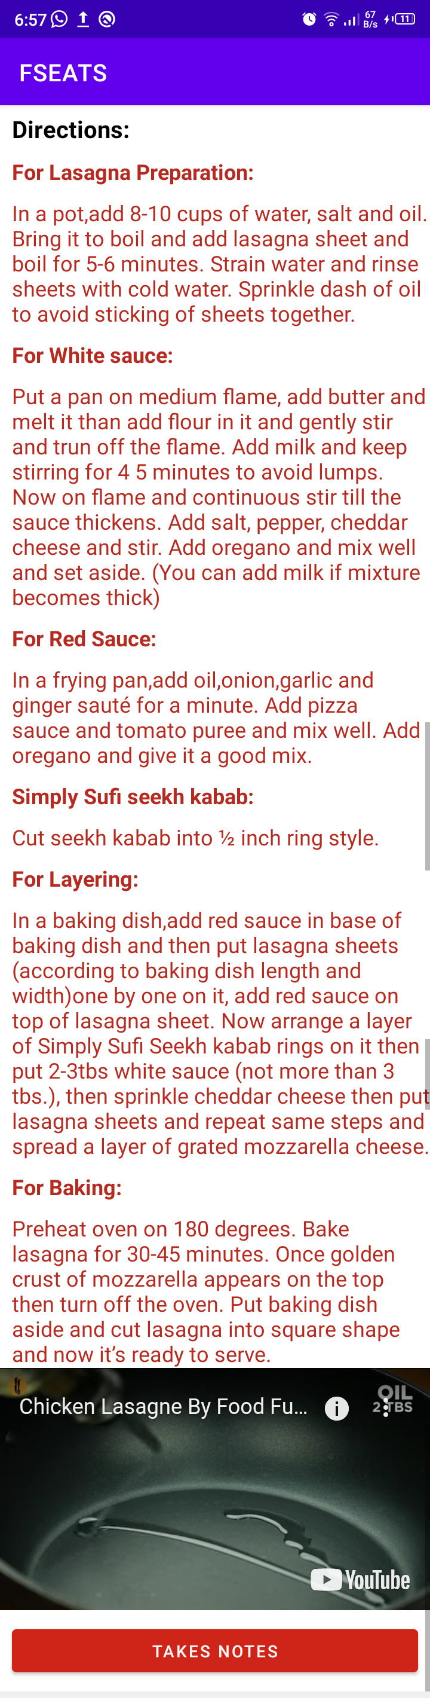

**Lasagna Recipe in Urdu**



**Takes Notes**

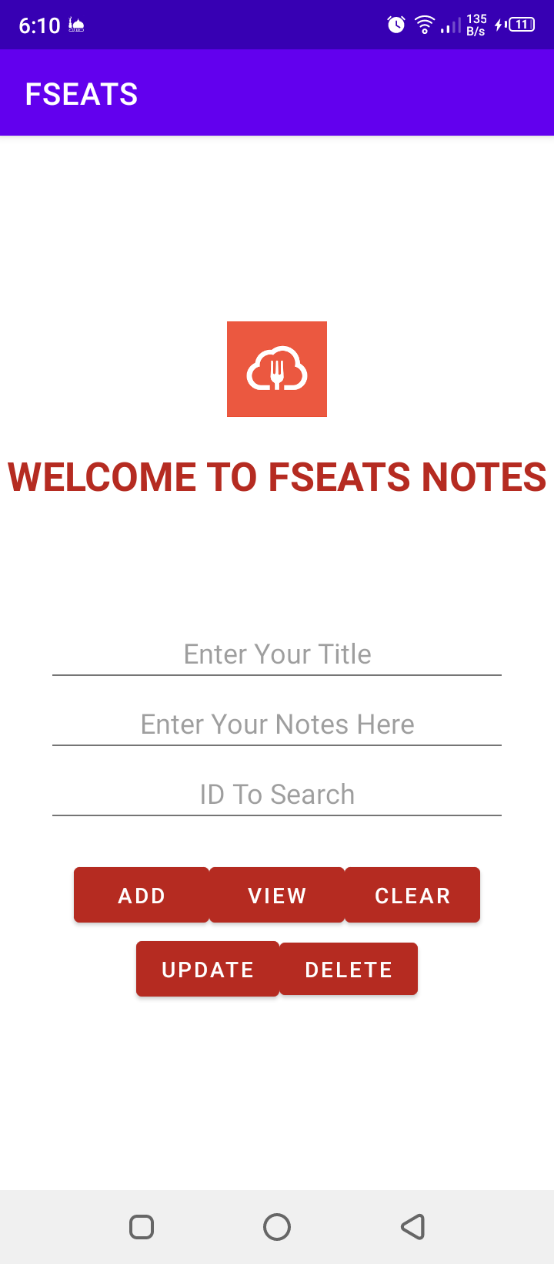

**Notes Inserted**

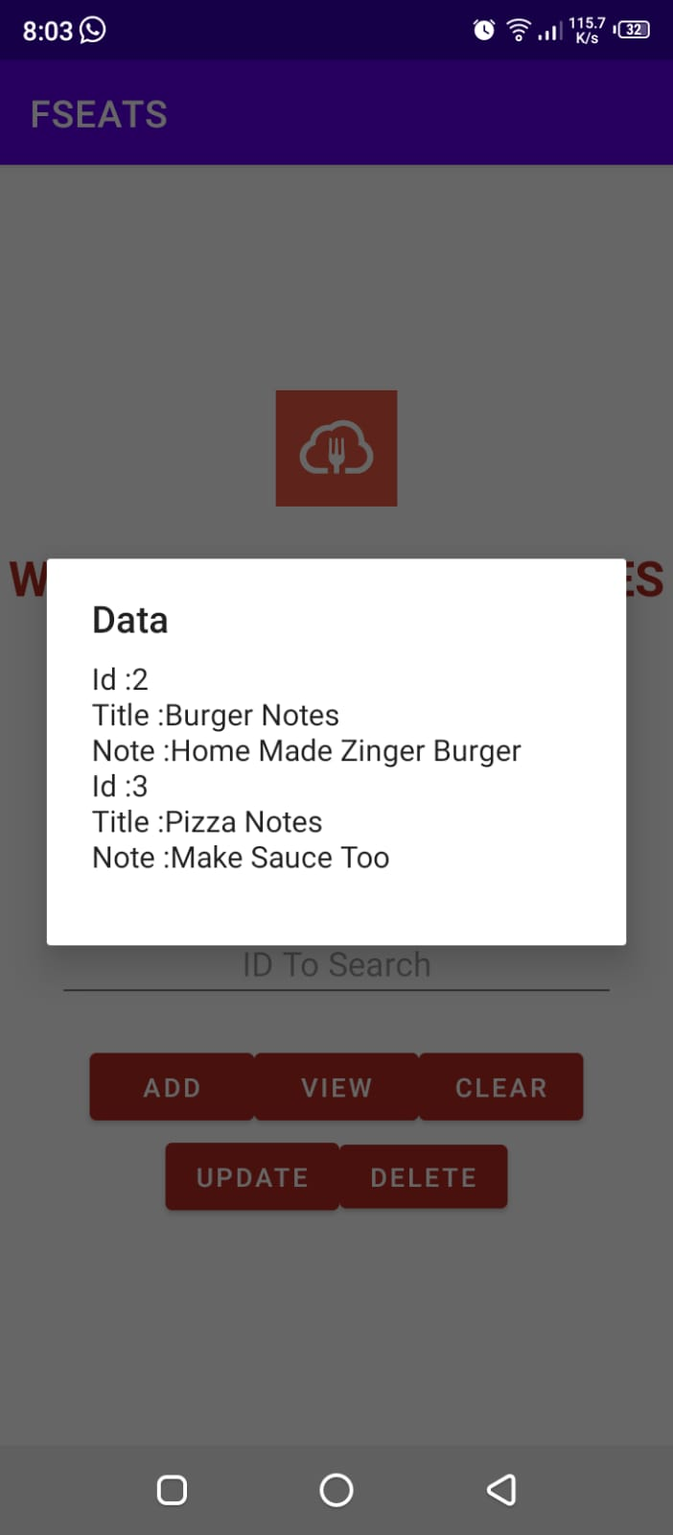

**Emulator View**

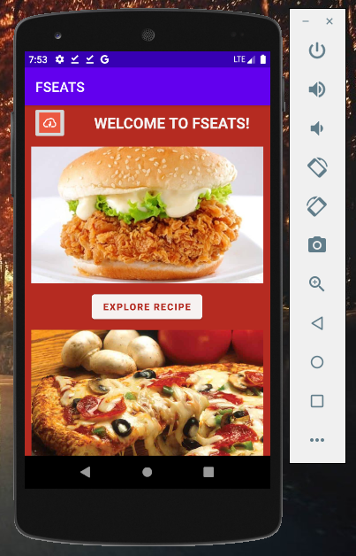

**Backend View**

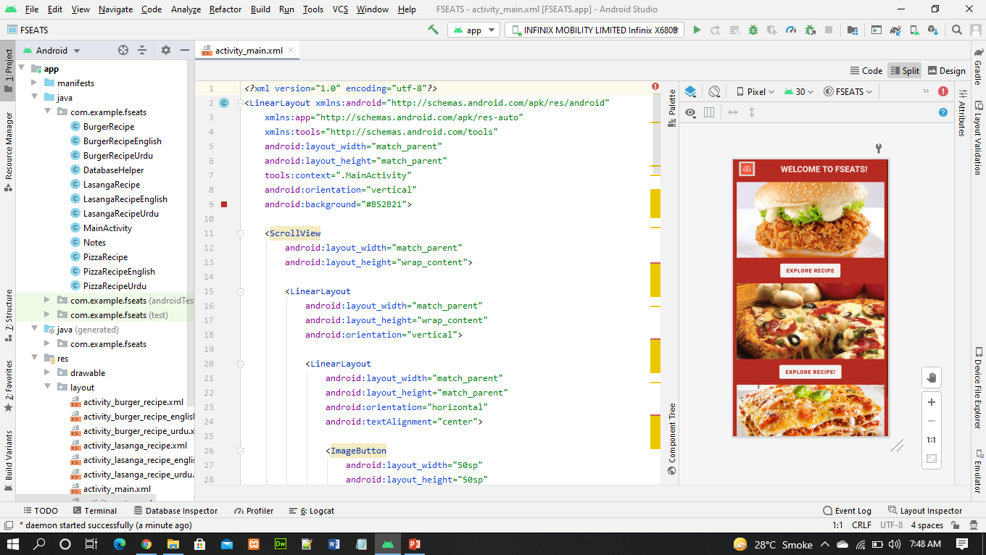

**Activity_main.XML**

<?xml version="1.0" encoding="utf-8"?>

<LinearLayout xmlns:android="http://schemas.android.com/apk/res/android"

xmlns:app="http://schemas.android.com/apk/res-auto"

xmlns:tools="http://schemas.android.com/tools"

android:layout_width="match_parent"

android:layout_height="match_parent"

tools:context=".MainActivity"

android:orientation="vertical"

android:background="#B52B21">

<ScrollView

android:layout_width="match_parent"

android:layout_height="wrap_content">

<LinearLayout

android:layout_width="match_parent"

android:layout_height="wrap_content"

android:orientation="vertical">

<LinearLayout

android:layout_width="match_parent"

android:layout_height="match_parent"

android:orientation="horizontal"

android:textAlignment="center">

<ImageButton

android:layout_width="50sp"

android:layout_height="50sp"

android:layout_marginLeft="12dp"

android:src="@drawable/logo"

android:scaleType="centerCrop">

</ImageButton>

<TextView

android:id="@+id/tvName"

android:layout_width="match_parent"

android:layout_height="wrap_content"

android:layout_marginLeft="10dp"

android:layout_marginTop="10dp"

android:text="WELCOME TO FSEATS!"

android:textAlignment="center"

android:textColor="#F6F2F1"

android:textSize="22dp"

android:textStyle="bold"></TextView>

</LinearLayout>

<ImageView

android:layout_margin="10dp"

android:layout_width="match_parent"

android:layout_height="200dp"

android:src="@drawable/burger"

android:scaleType="centerCrop">

</ImageView>

<androidx.constraintlayout.widget.ConstraintLayout

android:layout_width="match_parent"

android:layout_height="match_parent">

<Button

android:id="@+id/button"

android:layout_width="wrap_content"

android:layout_height="wrap_content"

android:layout_gravity="center_vertical"

android:backgroundTint="#F6F2F1"

android:text="EXPLORE RECIPE"

android:textColor="#B52B21"

android:textStyle="bold"

app:layout_constraintEnd_toEndOf="parent"

app:layout_constraintHorizontal_bias="0.498"

app:layout_constraintStart_toStartOf="parent"

tools:layout_editor_absoluteY="0dp"></Button>

</androidx.constraintlayout.widget.ConstraintLayout>

<ImageView

android:layout_margin="10dp"

android:layout_width="match_parent"

android:layout_height="200dp"

android:src="@drawable/pizza"

android:scaleType="centerCrop">

</ImageView>

<androidx.constraintlayout.widget.ConstraintLayout

android:layout_width="match_parent"

android:layout_height="match_parent">

<Button

android:id="@+id/button1"

android:layout_width="wrap_content"

android:layout_height="wrap_content"

android:layout_gravity="center_vertical"

android:backgroundTint="#F6F2F1"

android:text="EXPLORE RECIPE!"

android:textColor="#B52B21"

android:textStyle="bold"

app:layout_constraintEnd_toEndOf="parent"

app:layout_constraintHorizontal_bias="0.498"

app:layout_constraintStart_toStartOf="parent"

tools:layout_editor_absoluteY="0dp"></Button>

</androidx.constraintlayout.widget.ConstraintLayout>

<ImageView

android:layout_margin="10dp"

android:layout_width="match_parent"

android:layout_height="200dp"

android:src="@drawable/lasagna"

android:scaleType="centerCrop">

</ImageView>

<androidx.constraintlayout.widget.ConstraintLayout

android:layout_width="match_parent"

android:layout_height="match_parent">

<Button

android:id="@+id/button2"

android:layout_width="wrap_content"

android:layout_height="wrap_content"

android:layout_gravity="center_vertical"

android:backgroundTint="#F6F2F1"

android:text="EXPLORE RECIPE!"

android:textColor="#B52B21"

android:textStyle="bold"

app:layout_constraintEnd_toEndOf="parent"

app:layout_constraintHorizontal_bias="0.498"

app:layout_constraintStart_toStartOf="parent"

tools:layout_editor_absoluteY="0dp"></Button>

</androidx.constraintlayout.widget.ConstraintLayout>

</LinearLayout>

</ScrollView>

</LinearLayout>

**MainActivity.java**

package com.example.fseats;

import androidx.appcompat.app.AppCompatActivity;

import android.content.Intent;

import android.os.Bundle;

import android.view.View;

import android.widget.Button;

import android.widget.Toast;

public class MainActivity extends AppCompatActivity {

Button button,button1,button2;

@Override

protected void onCreate(Bundle savedInstanceState) {

super.onCreate(savedInstanceState);

setContentView(R.layout.activity_main);

button = (Button)findViewById(R.id.button);

button1 =(Button)findViewById(R.id.button1);

button2 =(Button)findViewById(R.id.button2);

button.setOnClickListener(new View.OnClickListener() {

@Override

public void onClick(View v) {

Toast.makeText(MainActivity.this, "Burger Recipe Selected", Toast.LENGTH_SHORT).show();

Intent intent = new Intent(MainActivity.this, BurgerRecipe.class);

startActivity(intent);

}

});

button1.setOnClickListener(new View.OnClickListener() {

@Override

public void onClick(View v) {

Toast.makeText(MainActivity.this, "Pizza Recipe Selected", Toast.LENGTH_SHORT).show();

Intent intent = new Intent(MainActivity.this,PizzaRecipe.class);

startActivity(intent);

}

});

button2.setOnClickListener(new View.OnClickListener() {

@Override

public void onClick(View v) {

Toast.makeText(MainActivity.this, "Lasagna Recipe Selected", Toast.LENGTH_SHORT).show();

Intent intent = new Intent(MainActivity.this, LasangaRecipe.class);

startActivity(intent);

}

});

}

}